Create a Website Backup Point in Wp-Engine

- Log into WP Engine
  - https://my.wpengine.com/
- Navigate to sites and select the website environment you need to backup
  - 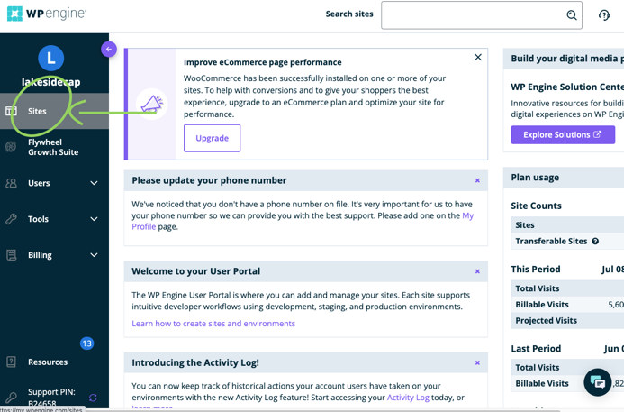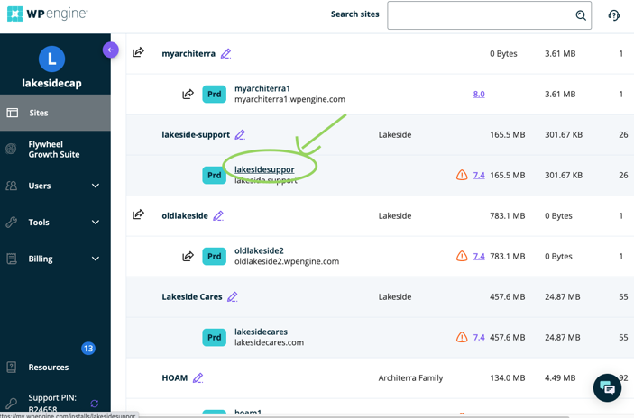
- Find “Backup points” on the left-hand side
  - 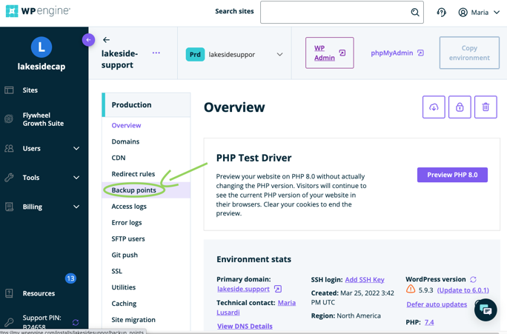
- Click the “create backup” button to create a new backup. Name your backup and type in the emails that should be notified when it is complete, including yours
  - Please always include lakesidecapital.marketing@gmail.com
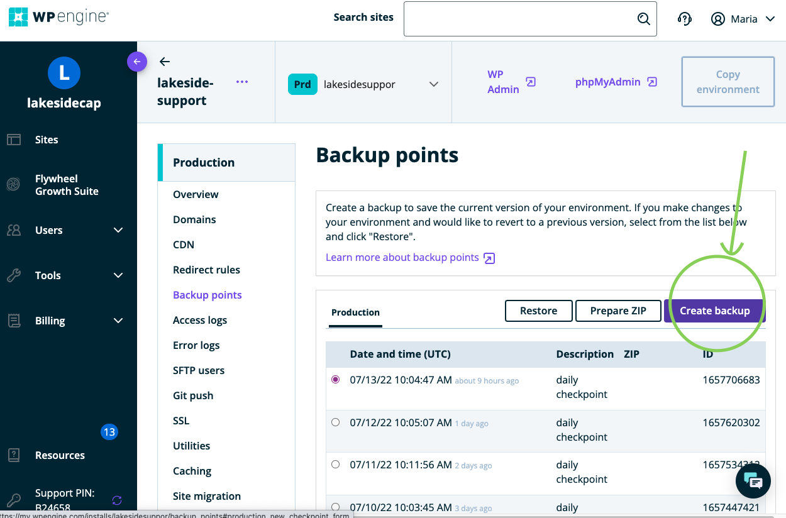
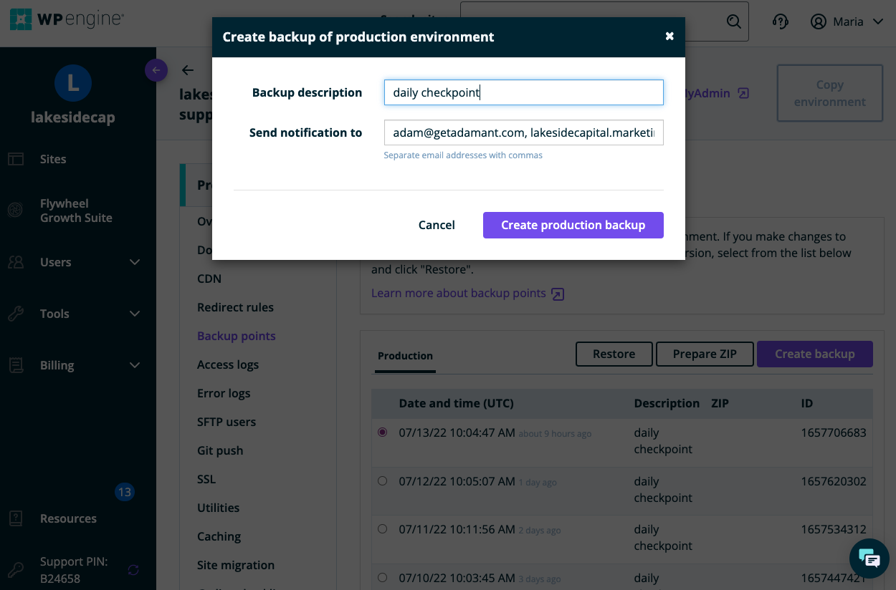
- WAIT FOR YOUR EMAIL NOTIFICATION before making any website changes
- Once you have been notified that the backup is complete, you can proceed with your website changes.

